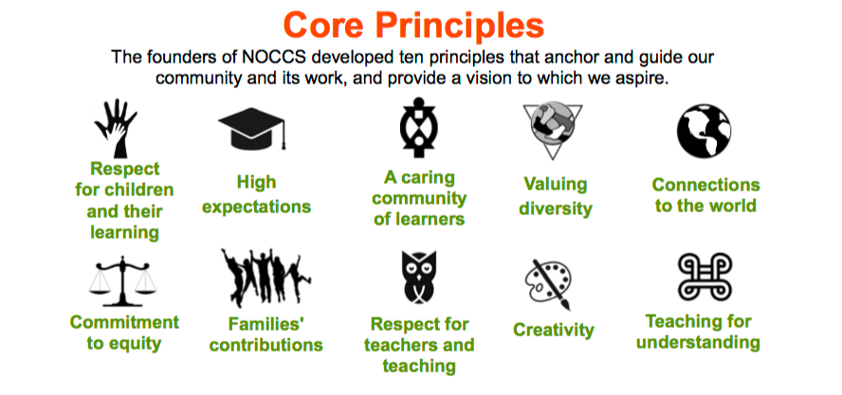
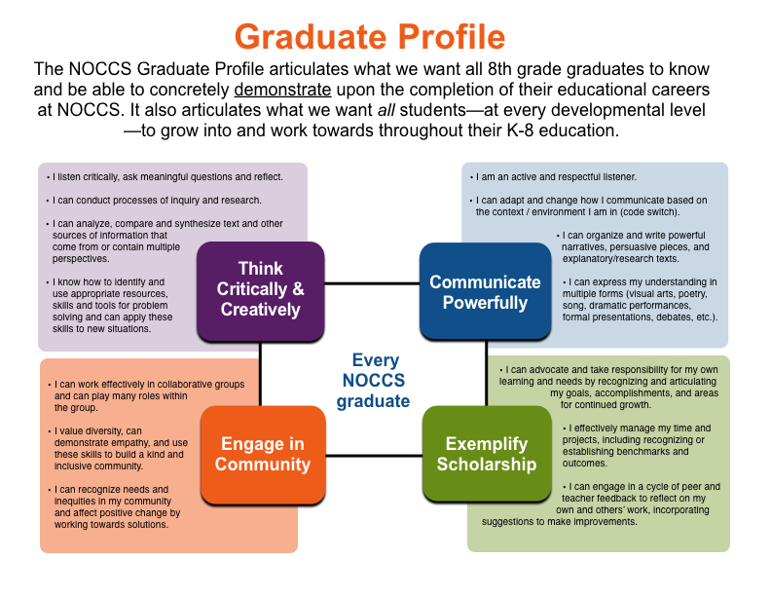

An Educated Person in the 21st Century
We believe an educated person in the 21st century is a life-long learner who possesses self-motivation, competence, and responsibility – this is firmly rooted in our school’s mission and vision.
We believe that an educated is person is a thoughtful, informed, and inquisitive citizen.
North Oakland Community Charter School will enable students to become thoughtful, informed and inquisitive citizens in the 21st Century by ensuring that all students can concretely demonstrate knowledge, skills, and habits in each of the following four domains of our NOCCS Graduate Profile: (1) critical and creative thinking, (2) powerful communication, (3) community engagement, and (4) exemplary scholarship.
Each of the domains of our Graduate Profile is further defined by a set of specific, developmentally appropriate outcomes that we support every student at NOCCS to concretely demonstrate throughout, at the completion of, and beyond their careers at our school. These include:
Creative and Critical Thinking
• I listen critically, ask meaningful questions, and reflect
• I conduct processes of inquiry and research
• I analyze, compare, and synthesize text and other sources of information that come from or contain multiple perspectives
• I identify and use appropriate resources, skills, and tools for problem solving and can apply these skills to new situations
Powerful Communication
• I am an active and respectful listener
• I adapt and change how I communicate based on the context/environment I am in
• I organize and write powerful narratives, persuasive pieces, and explanatory/research texts
• I express my understanding in multiple forms (visual arts, poetry, song, dramatic performances, formal presentations, debates, etc.)
Community Engagement
• I work effectively in collaborative groups and can play many roles within the group
• I value diversity, demonstrate empathy, and use these skills to build a kind and inclusive community
• I recognize needs and inequities in my community and affect positive change by working towards solutions
Exemplary Scholarship
• I advocate and take responsibility for my own learning and needs by recognizing and articulating my goals, accomplishments, and areas of continued growth
• I effectively manage my time and projects including recognizing or establishing benchmarks and outcomes
• I engage in a cycle of peer and teacher feedback to reflect on my own and others’ work, incorporating suggestions to make improvements

How Learning Best Occurs
Guiding Principles
The founders of the North Oakland Community Charter School developed ten principles that anchor and guide our community and its work, and provide a vision to which we aspire, including how we structure and carry forth our educational programming, inform our decision making, and shape our school climate and culture. Our guiding principles are:
Respect for children and their learning: At the heart of our school is a profound appreciation, attentiveness, and respect for children's ideas. Our teachers learn by looking closely at children's understanding, and how their questions and curiosity lead them to explore their world. The insights they garner from these observations inform their practice in a powerful way.
High expectations: We believe that attention to children's thinking goes hand in hand with the high expectations and rigorous academic standards we hold for children's work. Sharing, critiquing, and reflecting on student work help our students improve their work and performance. In this way, our school encourages children to reach beyond their limits.
A caring community of learners: Our school seeks to be a place where teachers, parents, and children create stable, warm, supportive relationships. We believe that the social climate is as important as the academic subjects taught in our classrooms. It is within the safe harbor of caring, compassionate relationships that children and adults are inspired to produce their best work.
Valuing diversity: We are committed to ensuring that the diversity of North Oakland is represented in our school -- its students, faculty, and governance. Our learning community seeks to be a dynamic exchange of the perspectives, talents, and ideas of all its members. Students, parents and faculty are encouraged to draw on, value, and respect the richness of their own and each other's cultures and histories, together with those of other communities.
Connections to the world: Our school seeks to bring the world into the classroom and the classroom into the world to create a vital exchange between the two. When children connect what they learn to the world they live in and the problems they face, they come to see their lives in a new way.
A commitment to equity: Our school believes that all children can learn at a high level and that any child's intellectual and social growth can be developed through practice and effort. Race, culture, income, and ethnicity will not be predictors of achievement. Instead, our school holds uncompromisingly high standards for all of its students, while providing active and flexible support to ensure their success.
Families' contributions: Families are their children's first and most important teachers. They create the bridge between the cultures that children bring from home to the one they create at school. Parents and caregivers understand their children -- their passionate interests, their character, and their learning styles. When they share their wealth of knowledge with teachers, both are better able to support children's social, academic, and intellectual growth.
Respect for teachers and teaching: Our teachers bring a deep understanding of subject matter, children and their learning, and the craft of teaching. We respect their knowledge and support their growth and development as professionals and learners.
Creativity: Our school seeks to be a place where learning is graced with the creativity and inventiveness of children. Art in all its forms – the visual arts, dance, music, drama, poetry, and storytelling – are routes for children to examine, interpret, and render the world. Art is a tool of the imagination, but it is also a vehicle of the intellect that allows children to demonstrate and construct their knowledge across the disciplines.
Teaching for understanding: In our school, teachers seek to design thought- provoking tasks that call on students to demonstrate a deep understanding of important subject matter. Using various forms of inquiry that engage their curiosity and wonder, students ask probing questions, conduct research, test their theories, make inferences, connect what they learn to the real world, and ultimately, apply their understanding on their own.
Educational Philosophy and Research-Based Pedagogical Principles
Directed by and aligned to our powerful guiding principles, NOCCS embraces and is built upon a progressive and equitable educational philosophy and program. A NOCCS education seeks to develop in all students the ability to think critically and creatively, communicate powerfully, engage in community, and exemplify scholarship in an increasingly complex and interconnected world.
We believe that deep and authentic learning – the type of understanding, thinking, and acting needed to succeed in the 21st century – occurs best when students are consistently challenged – from a very young age – to critically consider, analyze, and synthesize multiple viewpoints and sources of data; consciously understand and implement a variety of strategies when attempting to solve problems; effectively work both autonomously as well as collaboratively to develop, revise, expand and express their understanding of concepts and their demonstration of skills; and to authentically empathize and to work in a kind, caring manner to understand and resolve conflicts in a way that strengthens and builds our community of learners. As such, our educational program is centered around the following research–based pedagogical principles:
• Cognitive: The most powerful learning comes from developing sophisticated understanding of concepts and higher order thinking associated with various fields of inquiry (Bruner, 1966 & 1996; Wiggins & McTighe, 2005).
• Developmental: Schooling matches its activities to the developmental level of children and then accelerates learning. Investigating students' own questions should take precedence when studying content and teachers must “hook” students when necessary content does not naturally pique student interest (Bruner, 1966 & 1996; Piaget 1969; Wiggins & McTighe, 2005).
• Rigorous: Students learn best when faced with genuine challenges to think about new interpretations and possibilities, to see patterns and analyze them (Doll, 1993; Bruner, 1966; Vygotsky, 1978; Wiggins & McTighe, 2005).
• Promoting Critical Thinking: Children should be taught how to think and be offered questions to think about. Through authentic dialogue students develop an awareness of reality and bias which then helps them examine new possibilities (Burbules, 1993; Cortez, 1986; Freire, 1996; Olsen, 1999; Shor, 1992; Wiggins & McTigh,2005;).
• Reflective: Ample opportunities for learners to look back, to reflect, and to debrief about both what they know and don’t yet know must be provided (Dewey, 1971; Doll, 1993; Freire,1996).
• Authentic: Real, rich, complex ideas and materials are at the heart of the curriculum because active, hands-on, minds-on, concrete experiences are the most powerful form of learning. Children learn best when they encounter whole, real ideas, events, and materials in purposeful context and not by only studying sub-parts isolated from actual use. Content is made relevant by making connections to life outside the classroom (Doll, 1993; Gardner, 1991; Piaget, 1969; Wiggins & McTighe, 2005).
• Standards-Based: To adequately prepare students for academic success as measured by state indicators, our students will be fully immersed in the articulated content standards (Ainsworth, 2003).
• Collaborative: Cooperative learning activities tap the social power of learning especially for children learning a second language. Learning is socially constructed; students working together collaboratively in a variety of different groupings maximizes learning for all students regardless of their achievement levels (Cummins, 1986; Lindholm-Leary, 2001; Lazarowitz & Karsenty; Slavin, 1994; Vygotsky, 1978, 1990).
• Recursive: Ideas, concepts and themes are not just taught once and forgotten. They are revisited throughout a child’s education, building understandings into more sophisticated levels each time (Bruner, 1966; Dewey, 1971; Doll, 1993; Piaget, 1969; Whitehead, 1967; Wiggins and McTighe, 2005).
• Transformational: Children do not just receive knowledge; they create it within the cognitive systems they encounter; fostering new ways to see and act (Doll, 1993; Freire, 1996, Bruner,1966; Shor, 1992).
• Promoting the Development of Character: The classroom and school are model communities where students learn the skills and practices they need to live as productive citizens of the greater community. Students learn to take full responsibility for their own learning (Nelson, 2000; Kohn, 1993).
• Data-Driven: In order to be effective, teachers must provide instruction within a child’s zone of proximal development. In order to provide this finely calibrated

Areas of priority to realize academic vision across the school:

- Align both new and old staff around the academic vision of NOCCS and what it looks like in practice
- All staff will have an understanding of our Measurable Pupil Outcome and their role in ensuring we meet them
- Data driven teacher training, coaching and support
- All staff will understand and ensure student practice of Exemplify Scholarship from the graduate profile
- Commitment to equity(NOCCS core principle). Staff members will examine the achievement gap the exists among subgroups at NOCCS and understand their role in closing them

