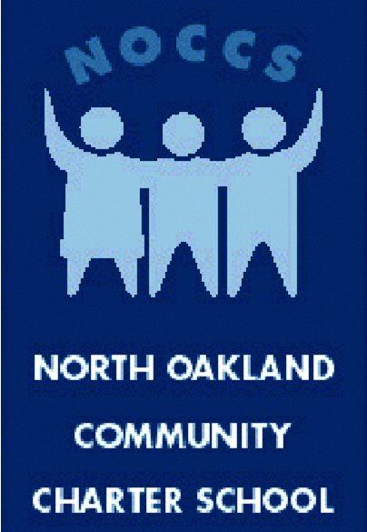

NORTH OAKLAND COMMUNITY CHARTER SCHOOL

1000 42nd Street, Oakland, CA 94608
tel. 510-655-0540, fax 510-655-1222
www.noccs.org
_______________________________________________________________

June 2017
State of School Report
To: North Oakland Community Charter School Board of Directors
From: Stephen Ajani, Head of School
Staffing

We are excited to welcome the following people into our school community:
- Jessica Shimamoto (4/5 Lead Teacher) is coming to us from Emerson ES.
- Alix Feinsod (6-8 Teacher Intern) is joining us with a background in teaching coding a passion for math instruction.
- Emani’ Lewis (Office Manager) joins us with experience in operations, performance management and community engagement.

Santa Fe Can RFI
Santa Fe Can has invited NOCCS to complete an RFI to partner with them to reopen Santa Fe ES. Through discussions with our Co-chairs and leadership team. We feel it makes sense for us to put our name in the hat. We have started to draft our submission in Google docs. Question for the board: What committees or individuals should review our submission?
Goal Setting
I am recommending two sets of goals for the 17-18 SY. School level goals(internal) and Organization Goals(board) both should be reported on monthly. My desired outcome here is to have both organizational and school level goals that people are bought into and accountable for.

NOCCS 2016-17 Goals
Core Value focus of the year
A caring community of learners: Our school seeks to be a place where teachers, parents, and children create stable, warm, supportive relationships. We believe that the social climate is as important as the academic subjects taught in our classrooms. It is within the safe harbor of caring, compassionate relationships that children and adults are inspired to produce their best work.
Goal #1: School Teacher support and leadership:
Measurable outcomes:
90% of school teachers are satisfied with the amount of support they receive.
90% of school teachers are satisfied with the amount of leadership opportunities provided to staff.
90% of school teachers will report learning or stealing a best practice from someone else on staff this year.
Updates
Progress made, goal not met. Increasing teacher support will continue to be a priority for NOCCS next year. For the 17-18 SY we will use data from the city wide teacher survey our teachers have taken the last two years.
Measurable questions for next year. 1-5 scale rating. Desired outcome is to receive rating of 4.2 for the following statements.
- In the last 6 months someone has talked to me about my progress
- In the last 7 days I have received praise for doing good work
- I have the materials I need every day to do my work right
Goal #2: Create a financially sustainable school model for NOCCS
Measurable Outcomes:
By January 2017, NOCCS will have decided and communicated with staff and families what steps we will be taking to determine the short term financial sustainability of NOCCS for the 2017-18 school year.
By January 2017, NOCCS will have decided and communicated with staff and families the steps we are considering to ensure our financial stability of the next 3 years.
Update
Progress made, goal not met.

Goal #3: Raise Oakland’s awareness of NOCCS and build relationships with key stakeholders in Oakland.
Measurable Outcomes:
Log over 10 staff hours of direct student recruitment in Northwest attendance area.
Host 10 key stakeholders by June (school board members, local elected officials, potential funders, etc.)
HoS will log 3 hours a month attending and hosting meetings related to education in Oakland
NOCCS will receive 3 applications for every one open seat
- Updates
- Goals met
Goal #4: Strengthen School Culture Measurable outcomes:
- 1. 85% of staff will agree they are part of a “caring community of learners”
- 2. 85% of parents will be satisfied with the student culture
- 3. 85% of returning teachers report feeling more supported in the 16-17 SY
- Update
- 1. Goal Met. Used similar question from ED78 survey
- 2. Goal Met @ 88%. However, responses to family survey was low.
- 3. Goal Met

